**Software Engineering Assignment**

**MODULE : 1**

SE – Overview of IT Industry

1. What is software?

Ans: - Software is a set of instructions, data or programs used to operate computers and execute specific tasks. It is the opposite of hardware, which describes the physical aspects of a computer. Software is a generic term used to refer to applications, scripts and programs that run on a device. It can be thought of as the variable part of a computer, while hardware is the invariable part.

The categories of software are below

* Application Software
* System Software
* Driver Software
* Middleware Software
* Programming Software

1. What is software engineering?

Ans: - The term **software engineering** is the product of two words, **software**, and **engineering.**

The **software** is a collection of integrated programs.

Software subsists of carefully-organized instructions and code written by developers on any of various particular computer languages.

Computer programs and related documentation such as requirements, design models and user manuals.

**Engineering** is the application of **scientific** and **practical** knowledge to **invent, design, build, maintain,** and**improve frameworks, processes, etc.**

2 **Explain types of software?**

Ans**: -** **Types of Software**

It is a collection of data that is given to the computer to complete a particular task. The list below describes the types of software:

1 – **System Software**

* Operating System
* Language Processor
* Device Driver

2 – **Application Software**

* General Purpose Software
* Customize Software
* Utility Software

## ****System Software****

[System software](https://www.geeksforgeeks.org/system-software/)is software that directly operates the [computer hardware](https://www.geeksforgeeks.org/computer-hardware/) and provides the basic functionality to the users as well as to the other software to operate smoothly. Or in other words, system software basically controls a computer’s internal functioning and also controls hardware devices such as monitors, printers, and storage devices, etc. It is like an interface between hardware and user applications, it helps them to communicate with each other because hardware understands machine language(i.e. 1 or 0) whereas user applications are work in human-readable languages like English, Hindi, German, etc. so system software converts the human-readable language into machine language and vice versa.

### **Types of System Software**

It has two subtypes which are:

1. **Operating System:** It is the main program of a computer system. When the computer system ON it is the first software that loads into the computer’s memory. Basically, it manages all the resources such as [computer memory](https://www.geeksforgeeks.org/computer-memory/), [CPU](https://www.geeksforgeeks.org/central-processing-unit-cpu/), [printer](https://www.geeksforgeeks.org/what-is-a-printer/), hard disk, etc., and provides an interface to the user, which helps the user to interact with the computer system. It also provides various services to other computer software. Examples of operating systems are [Linux](https://www.geeksforgeeks.org/introduction-to-linux-operating-system/), Apple macOS, [Microsoft Windows](https://www.geeksforgeeks.org/interesting-facts-about-windows/), etc.
2. **Language Processor:**As we know that system software converts the human-readable language into a machine language and vice versa. So, the conversion is done by the language processor. It converts programs written in high-level [programming languages](https://www.geeksforgeeks.org/introduction-to-programming-languages/) like[Java](https://www.geeksforgeeks.org/introduction-to-java/), [C](https://www.geeksforgeeks.org/c-plus-plus/),[C++](https://www.geeksforgeeks.org/c-plus-plus/), [Python](https://www.geeksforgeeks.org/history-of-python/), etc(known as source code), into sets of instructions that are easily readable by machines(known as object code or machine code).
3. **Device Driver:**A [device driver](https://www.geeksforgeeks.org/device-driver-and-its-purpose/)is a program or software that controls a device and helps that device to perform its functions. Every device like a printer, mouse, [modem](https://www.geeksforgeeks.org/how-to-install-a-modem/), etc. needs a driver to connect with the computer system eternally. So, when you connect a new device with your computer system, first you need to install the driver of that device so that your operating system knows how to control or manage that device.

### **Features of System Software**

Let us discuss some of the features of System Software:

* System Software is closer to the computer system.
* System Software is written in a low-level language in general.
* System software is difficult to design and understand.
* System software is fast in speed (working speed).
* System software is less interactive for the users in comparison to application software.

## ****Application Software:-****

Software that performs special functions or provides functions that are much more than the basic operation of the computer is known as [application software](https://www.geeksforgeeks.org/what-is-application-software/). Or in other words, application software is designed to perform a specific task for end-users. It is a product or a program that is designed only to fulfill end-users’ requirements. It includes word processors, [spreadsheets](https://www.geeksforgeeks.org/introduction-to-excel-spreadsheet/), database management, inventory, payroll programs, etc.

### **Types of Application Software**

There are different types of application software and those are:

1. **General Purpose Software:**This type of application software is used for a variety of tasks and it is not limited to performing a specific task only. For example, MS-Word, MS-Excel, PowerPoint, etc.
2. **Customized Software:**This type of application software is used or designed to perform specific tasks or functions or designed for specific organizations. For example, [railway reservation system](https://www.geeksforgeeks.org/railway-reservation-system-in-c/), airline reservation system, invoice management system, etc.
3. **Utility Software:**This type of application software is used to support the computer infrastructure. It is designed to analyse, configure, optimize and maintains the system, and take care of its requirements as well. For example, [antivirus](https://www.geeksforgeeks.org/how-an-antivirus-works/), disk fragmented, memory tester, disk repair, disk cleaners, registry cleaners, disk space analyser, etc.

### **Features of Application Software**

Let us discuss some of the features of Application Software:

* An important feature of application software is it performs more specialized tasks like word processing, spreadsheets, [email](https://www.geeksforgeeks.org/what-is-an-email/), etc.
* Mostly, the size of the software is big, so it requires more storage space.
* Application software is more interactive for the users, so it is easy to use and design.
* The application software is easy to design and understand.
* Application software is written in a high-level language in general.

3 What Is SDLC?

Ans: - The software development life cycle (SDLC) is a set of stages, activities, and tasks that software projects go through. The process outlines how software development teams build, test, deploy, and maintain their software to achieve top quality on time and within budget.

SDLC begins with the planning phase, where the development team defines and analyses the project requirements, goals, and timeline. After the planning phase, the team creates the prototype by designing, building, and integrating different components. Next, the developers evaluate the project, investigate any reported issues, and fix bugs to ensure the software works efficiently before the official launch.

While the goal is to ensure a quality and timely development process, the development cycle also involves routine maintenance to ensure the software remains running without hitches. When implemented correctly, these core SDLC activities provide several benefits. The following sections will dive more deeply into the importance of SDLC to businesses and development teams.

**Each Phase Of SDLC**: - All software development life cycle models involve various stages. Although these strategies can vary from model to model, we’ll look at the following SDLC sequence:

1. Planning
2. Requirement gathering and analysis
3. Designing
4. Building and developing
5. Testing
6. Implementation
7. Deployment
8. Maintenance

Q 5 What Is Flowchart?

ANS: - The Flowchart is the most widely used graphical representation of AN Algorithm and procedural design workflows. It uses various symbols to show the operations and decisions to be followed in a program. It flows in sequential order”

**“The process of drawing a flowchart for an algorithm is known as “flowcharting”.”**

**Algorithm**: - An Algorithm is a step-by-step procedure to solve a given problem.

Algorithm of add two numbers

Start

Declare variable n1, n2

Read the values for n1 and n2

Sum >n1 +n2

Display sum

Stop

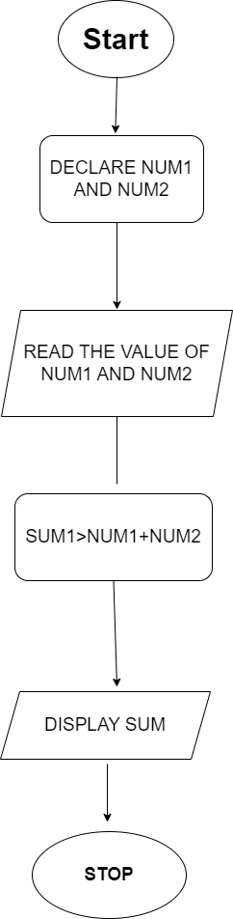 **FLOWCHART**

6 What Is Use Case Diagram?

Ans: - In the Unified Modeling Language (UML), a use case diagram can summarize the details of your system's users (also known as actors) and their interactions with the system. To build one, you'll use a set of specialized symbols and connectors. An effective use case diagram can help your team discuss and represent:

* Scenarios in which your system or application interacts with people, organizations, or external systems
* Goals that your system or application helps those entities (known as actors) achieve
* The scope of your system

6 A use case on bill payment on paytm.

Start

Login

Payments

Send Money To Anyone

Scan &Pay

Money Transfer

Success & Failed

Balance & History

Support

Stop

**Paytm Money Transfer Use Case Diagram**

f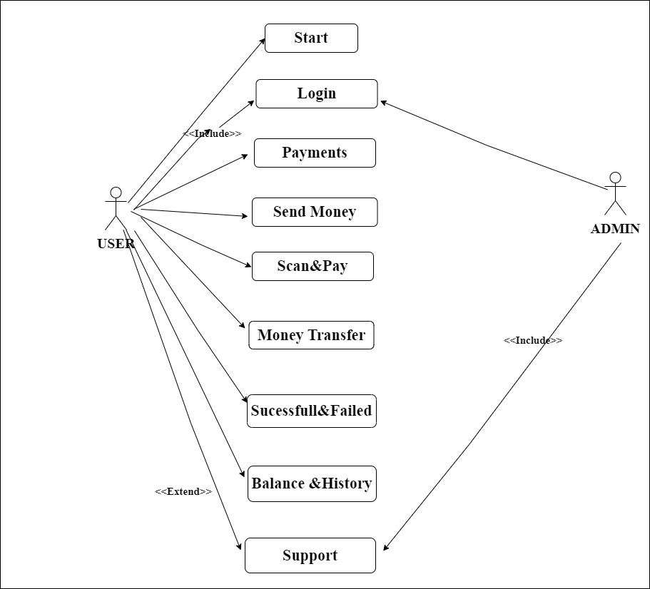

**Q 5 What Is DFD?**

ANS: - Data Flow Diagram (DFD) is a traditional visual representation of the information flows within a system. A neat and clear DFD can depict the right amount of the system requirement graphically. It can be manual, automated, or a combination of both.



It shows how data enters and leaves the system, what changes the information, and where data is stored.

The objective of a DFD is to show the scope and boundaries of a system as a whole. It may be used as a communication tool between a system analyst and any person who plays a part in the order that acts as a starting point for redesigning a system. The DFD is also called as a data flow graph or bubble.



Symbol Name Function

Data Flow Used To Connect Processes to each

other ,to sources or sinks ; te arrow

Head indicates direction of data flow.

Process Performs Some Transformation of

Input data to yield output data.

Source of sink A Source of System inputs or Sink

(External Entity) of system outputs.

Data Store A repository of data ; the arrow

Heads indicate net inputs and net

Outputs to store.

**ANS:-DFD Diagram on Flipkart**

**Zero level data flow diagram on Flipkart Shopping System.**

This is the Zero Level DFD of Flipkart Shopping System, where we have elaborated the high level process of Shopping System. It's a basic overview of the whole Flipkart Shopping System or process being analyzed or modeled. It's designed to be an at-a-glance view of Product, Delivery and Confirm Order showing the system as a single high-level process, with its relationship to external entities of Shopping, Shopping Cart and Order. It should be easily understood by a wide audience, including Shopping Order and Product In zero level DFD of Flipkart Shopping System.

High Level Entities and process flow of Flipkart Shopping System:

* Managing all the Shopping
* Managing all the Shopping Cart
* Managing all the Order
* Managing all the Payment
* Managing all the Product
* Managing all the Delivery
* Managing all the Confirm Order

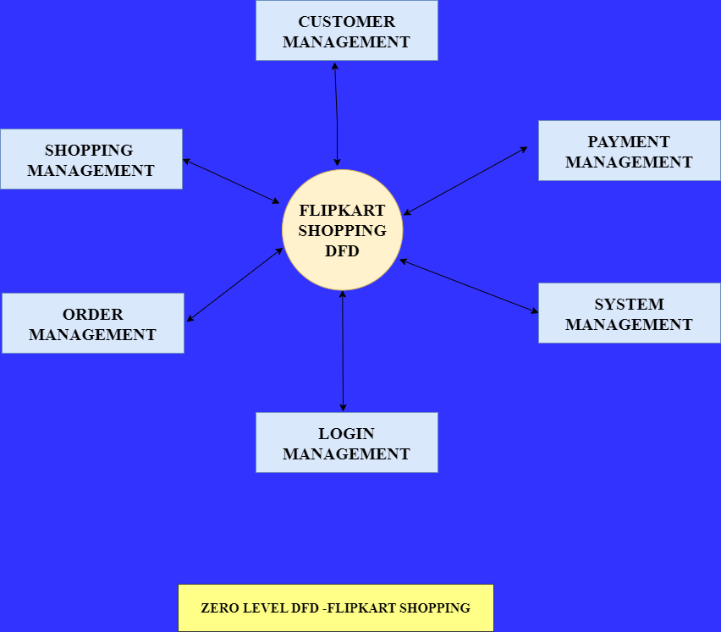

**First Level Data Flow Diagram First Level DFD Of Flipkart Shopping App:**

First Level DFD (1st Level) of Flipkart Shopping App shows how the system is divided into sub-systems (processes), each of which deals with one or more of the data flows to or from an external agent, and which together provide all of the functionality of the Flipkart Shopping App as a whole. It also identifies internal data stores of Confirm Order, Delivery, Product, Payment, Order that must be present in order for the Flipkart App do its job, and shows the flow of data between the various parts of Shopping, Order, Delivery, Confirm Order, Product of the system. DFD Level 1 provides a more detailed breakout of pieces of the 1st level DFD. You will highlight the main functionalities of Flipkart App.

**Main entities and output of First Level DFD (Ist Level DFD):**

* Processing Shopping records and generate report of all Shopping
* Processing Shopping Cart records and generate report of all Shopping Cart
* Processing Order records and generate report of all Order
* Processing Payment records and generate report of all Payment
* Processing Product records and generate report of all Product
* Processing Delivery records and generate report of all Delivery
* Processing Confirm Order records and generate report of all Confirm Order.

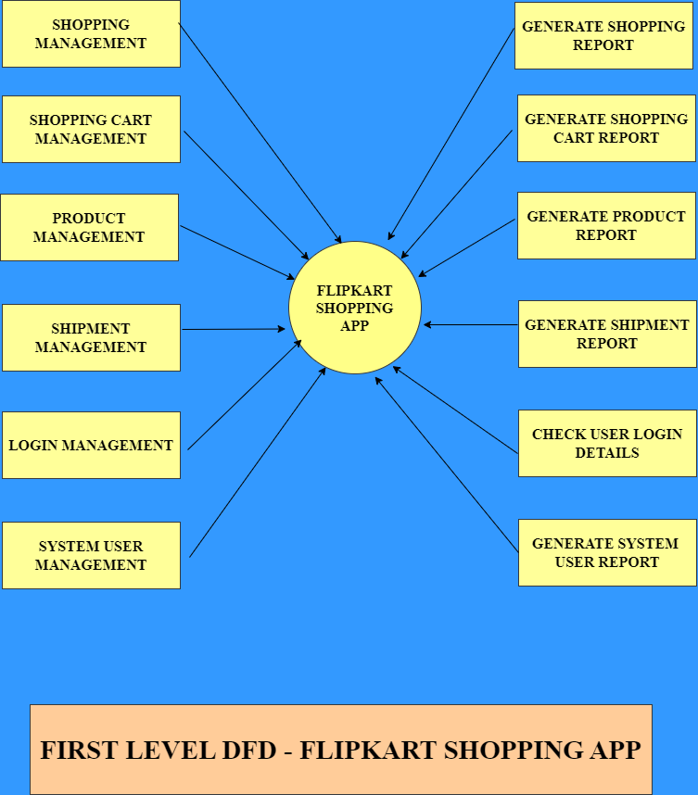

**Second Level Data Flow Diagram ({2nd Level DFD) Of Flipkart Shopping App:**

DFD Level 2 then goes one step deeper into parts of Level 1 of Shopping App.

It may require more functionalities of Shopping App to reach the necessary level of detail about the Shopping App functioning. First Level DFD (1st Level) of Flipkart Shopping App shows how the system is divided into sub-systems (processes). The 2nd Level DFD contains more details of Confirm Order, Delivery, Product, Payment, Order,Shopping Cart, Shopping.

**Second level functionalities of Flipkart Shopping App:-**

* Admin logins to the system and manage all the functionalities
* of Flipkart Shopping App.
* Admin can add, edit, delete and view the records of Shopping, Order, Product, Confirm Order.
* Admin can manage all the details of Shopping Cart,Payment, Delivery.
* Admin can also generate reports of Shopping, Shopping Cart, Order, Payment, Product, Delivery.
* Admin can search the details of Shopping Cart, Product,Delivery.
* Admin can apply different level of filters on report of Shopping, Payment, Product.
* Admin can tracks the detailed information of Shopping Cart,Order, Payment, , Product.

Below

